**Big O Analysis:**

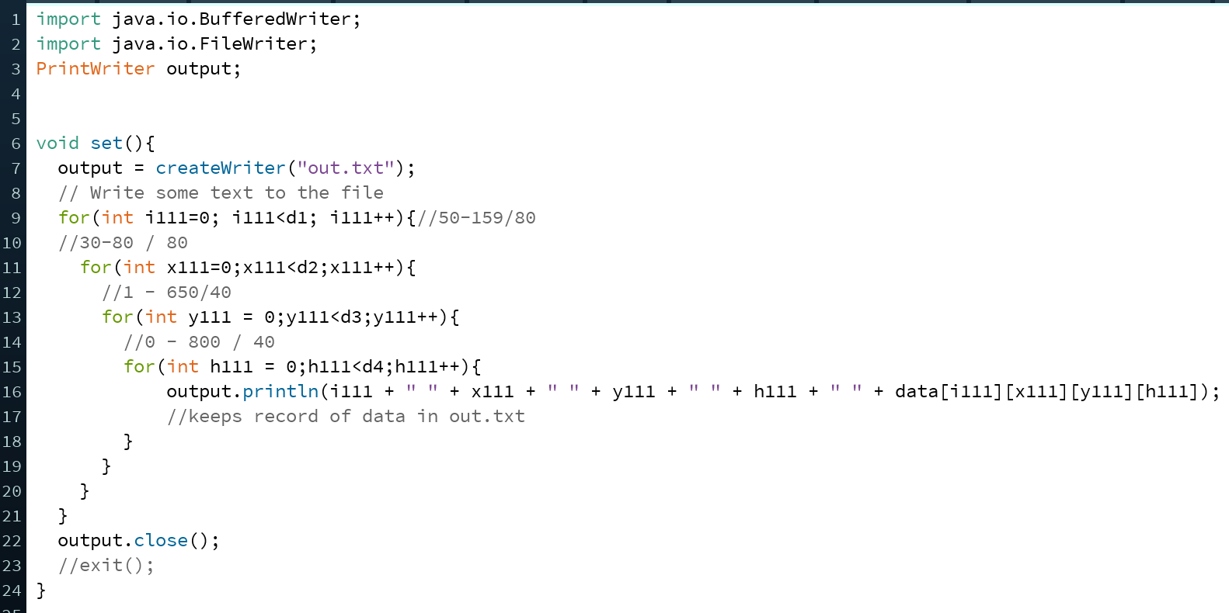

Since there are 4 nested for loops in the method set(), it takes O(n4) time.

We faced troubling when choosing this algorithm because of this runtime, however, if we did a BST for our data sets, the traversals took too long and the game lagged. Therefore, we chose to sacrifice space for the O(1) retrieving rate in a 4d array because we value user experience above space and memory.

Gamepage() is a method of O(n) time. Most of the methods that it calls, such as display() or grav() or move(), are methods of O(1) time that execute a set number of steps. The exception is a for loop in gamepage(). Inside the for loop, all of the methods are O(1) time, making the for loop cause Gamepage to be of O(n) time.

s13() is a method of O(n) time. Similar to Gamepage(), it executes many steps of time O(1) such as display() or getting an element from an ArrayList. In s13(), there are two for loops, that each run through n times. However, the for loops are not within one another, making the overall s13() to be of O(n) time.